**Noah Mousseau**

**CSC 4330 Sec 001**

**HW1 Activity and Intents – “Hello Toast” Enhancement**

**Steps to Enhance:**

1. Create a new activity using the empty template
   1. Create 2 new textviews within this new activity, one should just be labelled with “Hello!”, the other with a default string (I used %d as a placeholder to move the value from the initial activity to the new activity)
   2. Add any attributes, like centering and font sizes, that are required for better viewing
2. Open the initial toast_activity.java file
   1. Be sure to import the intent class
   2. Edit the showToast method:
      1. I used these lines:
         1. Intent intent = new Intent(this, show_count_activity.class);
         2. intent.putExtra("count", mCount);
         3. startActivity(intent);
      2. These lines create a new intent with this as the passing value, and the second value set to the second, newly created activity
      3. The putExtra line adds the mCount value to the intent
      4. The third line moves the active view and activity to the second, newly created activity
3. Open the new activity file, for me, this was show_count_activity.java
   1. Be sure to import the intent class
   2. First, get the count value from the intent passed from the toast_activity.java
      1. Intent intent = getIntent();
      2. int count = intent.getIntExtra("count", 0);
   3. Second, format the string from the count value
      1. String formattedString = String.format(getResources().getString(R.string.hello_activity_count), count);
   4. Third, set the new string to the TextView placeholder %d on the activity
      1. TextView countText = findViewById(R.id.activity_show_count_number);
      2. countText.setText(formattedString)

**App Starting Screen**

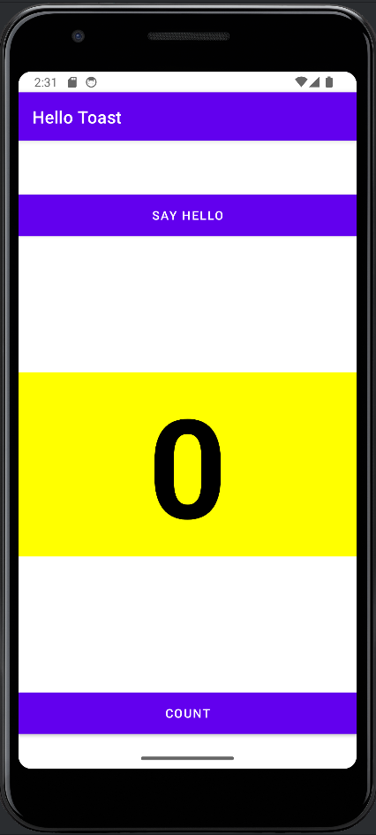

**Count Incremented**

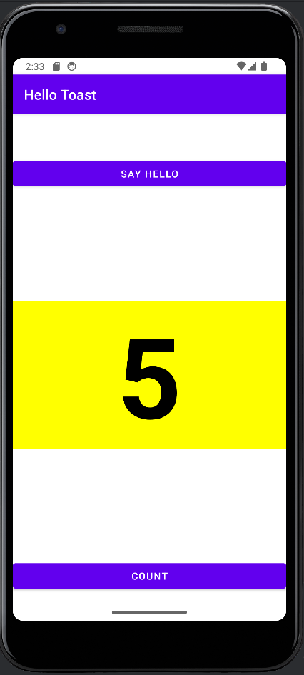

**Hello Activity Screen**

